For a fresher Data Analyst/Data Scientist interview, nobody can guarantee "every possible SQL question," because interviewers can ask anything. However, I can give you a high-coverage SQL interview checklist that covers about 90–95% of SQL questions commonly asked in companies like NielsenIQ, Accenture, Deloitte, Infosys, TCS, and Capgemini.
PART 1: SQL THEORY QUESTIONS
SQL Basics
- What is SQL?
- Difference between SQL and MySQL?
- What are the different SQL commands?
- What is a database?
- What is a table?
- What is a row and column?
- What is a schema?

Keys
- What is a Primary Key?
- What is a Foreign Key?
- Difference between Primary Key and Foreign Key?
- What is a Composite Key?
- What is a Candidate Key?
- What is a Unique Key?
- Can a Primary Key contain NULL values?

Constraints
- What are constraints?
- NOT NULL vs UNIQUE?
- CHECK constraint?
- DEFAULT constraint?
- AUTO_INCREMENT?

Joins
- What is JOIN?
- INNER JOIN?
- LEFT JOIN?
- RIGHT JOIN?
- FULL OUTER JOIN?
- CROSS JOIN?
- SELF JOIN?
- Difference between INNER and LEFT JOIN?
- Difference between CROSS JOIN and INNER JOIN?
- When would you use SELF JOIN?

WHERE / HAVING
- Difference between WHERE and HAVING?
- Can aggregate functions be used in WHERE?
- Why is HAVING needed?

GROUP BY
- What is GROUP BY?
- Why is GROUP BY used?
- GROUP BY vs DISTINCT?

Aggregate Functions
- COUNT()
- SUM()
- AVG()
- MAX()
- MIN()
- Difference between COUNT(*) and COUNT(column)?

Subqueries
- What is a Subquery?
- Correlated vs Non-Correlated Subquery?
- When should Subqueries be used?

CTEs
- What is a CTE?
- Advantages of CTE?
- Difference between CTE and Subquery?

Window Functions
- What is a Window Function?
- ROW_NUMBER()
- RANK()
- DENSE_RANK()
- LAG()
- LEAD()
- Difference between RANK and DENSE_RANK? (already memtioned in highlighted yellow section in 50 and 51 question)

Indexing
- What is an Index?
- Why use Indexes?
- Advantages and disadvantages of Indexes?

Normalization
- What is Normalization?
- 1NF?
- 2NF?
- 3NF?
- Advantages of Normalization?
- What is Denormalization?

Views
- What is a View?
- Why use Views?
- Difference between View and Table?

Transactions
- What is a Transaction?
- COMMIT?
- ROLLBACK?
- SAVEPOINT?

ACID Properties
- What are ACID properties?
- Atomicity?
- Consistency?
- Isolation?
- Durability?

PART 2: PRACTICAL SQL QUESTIONS
Beginner
- Select all records.
- Select specific columns.
- Filter rows using WHERE.
- Use ORDER BY.
- Use LIMIT.
- Use DISTINCT.
- Find NULL values.
- Replace NULL values.

Aggregation
- Count total employees.
- Find average salary.
- Find maximum salary.
- Find minimum salary.
- Find department-wise salary.

GROUP BY
- Count employees per department.
- Average salary by department.
- Highest salary by department.

Joins
- Employee and Department table JOIN.
- LEFT JOIN example.
- Find employees without departments.
- SELF JOIN manager-employee relationship.

Intermediate Queries
- Second highest salary.
- Third highest salary.
- Top 3 salaries.
- Duplicate records.
- Remove duplicates.
- Employees earning above average salary.
- Departments with more than 5 employees.

Window Functions
- ROW_NUMBER example.
- RANK example.
- DENSE_RANK example.
- Running total.
- Department-wise ranking.

Date Functions
- Current date.
- Difference between two dates.
- Employees hired in last 30 days.
- Monthly sales report.

String Functions
- Convert to uppercase.
- Convert to lowercase.
- Extract first name.
- Count characters.
- Remove spaces.

Case Statements
- Categorize salaries:
- High
- Medium
- Low
- Create custom labels.

Advanced
- Find nth highest salary.
- Consecutive days login.
- Running total sales.
- Moving average.
- Customer retention query.
- Top-selling products.
- Most profitable category.

MOST IMPORTANT PRACTICAL QUESTIONS
If you are short on time, master these first:
- Second Highest Salary
- Nth Highest Salary
- Employee earning above average salary
- Duplicate Records
- Remove Duplicates
- INNER JOIN
- LEFT JOIN
- SELF JOIN
- GROUP BY + HAVING
- ROW_NUMBER()
- RANK()
- DENSE_RANK()
- Running Total
- Top N Records
- Department-wise Highest Salary
- Customers with Highest Purchases
- Monthly Sales Analysis
- CTE-based Queries
- Date Difference Queries
- NULL Handling
For your target companies and roles, if you can confidently answer the 74 theory questions and solve the 50 practical questions above without help, you'll be well prepared for most fresher SQL interviews in analytics and data science.

Excellent. This is exactly the right approach.
Don't just memorize definitions. For interviews, you need to answer in a way that sounds like someone who actually understands databases.
I'll act as the interviewer and give you the interview-quality answers you should know.

1. What is SQL?
Short Interview Answer
SQL (Structured Query Language) is a standard language used to communicate with relational databases. It is used to store, retrieve, update, delete, and manage data in databases.
Stronger Answer
SQL stands for Structured Query Language. It is used to interact with relational databases such as MySQL, PostgreSQL, SQL Server, and Oracle. Using SQL, we can perform operations like data retrieval, insertion, updating, deletion, table creation, and database management.
Example
SELECT * FROM Employees;
This retrieves all records from the Employees table.

Interview Tip
If the interviewer asks:
Have you used SQL?
Don't say:
Yes, I know SQL.
Instead say:
Yes. I have used SQL extensively for data analysis, including joins, subqueries, aggregations, CTEs, and window functions while working on analytics projects.
That immediately sounds more professional.

2. Difference Between SQL and MySQL?
This is one of the most common fresher questions.
Interview Answer
SQL | MySQL
SQL is a language. | MySQL is a database management system.
Used to interact with databases. | Used to store and manage data.
Standard language. | Software product that implements SQL.

Simple Analogy
Think of:
- English = Language
- Microsoft Word = Software using English
Similarly:
- SQL = Language
- MySQL = Software using SQL

Strong Interview Answer
SQL is a language used to interact with databases, whereas MySQL is a Relational Database Management System (RDBMS) that uses SQL to store and manage data.

3. What are Different SQL Commands?
Main Categories
DDL
Data Definition Language
Used for structure.
Commands:
CREATE
ALTER
DROP
TRUNCATE
Example:
CREATE TABLE Employees(
id INT,
name VARCHAR(50)
);

DML
Data Manipulation Language
Used for data.
Commands:
INSERT
UPDATE
DELETE
Example:
INSERT INTO Employees
VALUES(1,'Pranav');

DQL
Data Query Language
Command:
SELECT
Example:
SELECT * FROM Employees;

DCL
Data Control Language
Commands:
GRANT
REVOKE
Used for permissions.

TCL
Transaction Control Language
Commands:
COMMIT
ROLLBACK
SAVEPOINT
Used for transactions.

Interview Answer
SQL commands are mainly classified into five categories: DDL, DML, DQL, DCL, and TCL. DDL is used for defining database structures, DML for manipulating data, DQL for retrieving data, DCL for access control, and TCL for transaction management.

4. What is a Database?
Interview Answer
A database is an organized collection of related data that can be easily stored, managed, and accessed electronically.
Example
A hospital database may contain:
- Patients
- Doctors
- Appointments
- Treatments
All stored in related tables.

5. What is a Table?
Interview Answer
A table is a database object that stores data in rows and columns.
Example
Employees Table
EmpID | Name | Salary
1 | Pranav | 50000
2 | Amit | 60000

6. What is a Row and Column?
Interview Answer
Row
A row represents one complete record.
Example:
EmpID | Name | Salary
1 | Pranav | 50000
This entire line is one row.

Column
A column represents one attribute.
Example:
Salary
50000
60000
Salary is a column.

Strong Interview Answer
A row represents a single record in a table, while a column represents a specific attribute or field of the data.

7. What is a Schema?
This question often confuses freshers.
Interview Answer
A schema is the logical structure of a database that defines how data is organized, including tables, columns, relationships, constraints, and other database objects.
Example
Hospital Schema:
Tables:
Patients
Doctors
Appointments
Treatments
Relationships:
Patient_ID
Doctor_ID
Appointment_ID
Together they form the schema.

Simple Definition
Think of a schema as:
The blueprint of a database.

Yes. We’ll continue the theory revision from Keys — Questions 8 to 14 and keep the answers short, interview-ready, and easy to paste into your notes.
8. What is a Primary Key?
A Primary Key is a column or combination of columns that uniquely identifies each row in a table.
A Primary Key:
- must contain unique values
- cannot contain NULL values
- only one Primary Key constraint exists per table
Example:
CREATE TABLE employees (
emp_id INT PRIMARY KEY,
emp_name VARCHAR(50)
);
Short interview answer:
A Primary Key uniquely identifies each record in a table and cannot contain duplicate or NULL values.

9. What is a Foreign Key?
A Foreign Key is a column or combination of columns in one table that refers to a Primary Key or Unique Key in another table.
It is used to create a relationship between tables and maintain referential integrity.
Example:
CREATE TABLE departments (
dept_id INT PRIMARY KEY,
dept_name VARCHAR(50)
);

CREATE TABLE employees (
emp_id INT PRIMARY KEY,
emp_name VARCHAR(50),
dept_id INT,
FOREIGN KEY (dept_id) REFERENCES departments(dept_id)
);
Here, dept_id in employees is a Foreign Key.
Short interview answer:
A Foreign Key is a column that references a key in another table and is used to maintain relationships and referential integrity between tables.

10. Difference between Primary Key and Foreign Key?
Primary Key | Foreign Key
Uniquely identifies a row | Creates a relationship between tables
Cannot contain NULL | Can contain NULL, unless restricted
Cannot contain duplicate values | Duplicate values are allowed
One Primary Key constraint per table | A table can have multiple Foreign Keys
Usually defined in the parent table | Usually refers to a parent table
Short interview answer:
A Primary Key uniquely identifies records within a table, while a Foreign Key references a key in another table to establish a relationship between the tables.

11. What is a Composite Key?
A Composite Key is a key made up of two or more columns together that uniquely identify a row.
Example:
student_id course_id
101 C1
101 C2
102 C1
Neither student_id nor course_id alone is unique, but together:
(student_id, course_id)
uniquely identify each record.
SQL example:
CREATE TABLE enrollments (
student_id INT,
course_id INT,
PRIMARY KEY (student_id, course_id)
);
Short interview answer:
A Composite Key is a key formed using two or more columns that together uniquely identify a record.

12. What is a Candidate Key?
A Candidate Key is any column or set of columns that can uniquely identify each record in a table.
There can be multiple Candidate Keys, but only one is selected as the Primary Key.
Example:
Employees

emp_id
email
aadhaar_no
If all three are unique, all three can be Candidate Keys.
Suppose we select:
emp_id
as the Primary Key.
Then email and aadhaar_no are still Candidate Keys, but not the Primary Key.
Short interview answer:
A Candidate Key is a column or combination of columns that can uniquely identify a row and is eligible to become the Primary Key.

13. What is a Unique Key?
A Unique Key is a constraint that ensures that values in a column or set of columns are unique.
Example:
CREATE TABLE employees (
emp_id INT PRIMARY KEY,
email VARCHAR(100) UNIQUE
);
Here:
emp_id → Primary Key
email → Unique Key
The email column cannot contain duplicate values.
One important point: NULL handling for UNIQUE can differ between database systems, so in interviews it is safer to say that a Unique Key enforces uniqueness but is not the same as a Primary Key.
Short interview answer:
A Unique Key ensures that values in a column are unique and is commonly used for fields that must not contain duplicate values.

14. Can a Primary Key contain NULL values?
No.
A Primary Key cannot contain NULL because every row must have a definite value that uniquely identifies it.
For example, this is invalid:
emp_id emp_name
101 Mohan
NULL Rajesh
If emp_id is the Primary Key, NULL is not allowed.
Short interview answer:
No. A Primary Key cannot contain NULL values because it must uniquely and reliably identify every record in the table.

- What is a Window Function?
A window function performs a calculation across a set of related rows while keeping every individual row in the result.
Difference between GROUP BY and Window Function
GROUP BY combines multiple rows into one row per group, whereas a window function performs calculations on a group of rows without reducing the number of rows.
Example:
SELECT dept_name, MAX(salary)
FROM employees
GROUP BY dept_name;
This gives one row per department.
But:
SELECT *,
MAX(salary) OVER(PARTITION BY dept_name) AS max_salary
FROM employees;
keeps all employees and shows the maximum salary of their department beside each row.
Short interview answer
GROUP BY collapses rows and returns one result per group, whereas window functions perform calculations over groups while preserving the individual rows.
You can remember it simply as:
GROUP BY → reduces rows
Window Function → keeps rows

- What is ROW_NUMBER()?

ROW_NUMBER() is a window function that assigns a unique sequential number to each row based on the order specified inside the OVER() clause.
Even if two rows have the same value, ROW_NUMBER() still gives them different numbers.
Short interview answer:

ROW_NUMBER() is a window function that assigns a unique sequential number to each row. With PARTITION BY, the numbering restarts for each group, and ORDER BY determines the sequence.

SELECT *,
ROW_NUMBER() OVER(
PARTITION BY dept_name
ORDER BY emp_id
) AS rn
FROM employees;
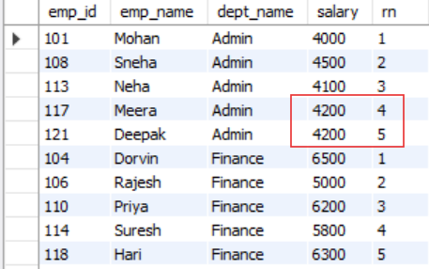

- What is RANK()?

RANK() is a SQL window function that assigns a rank to each row based on the order specified in the ORDER BY clause.
If two or more rows have the same value, they receive the same rank, and the next rank is skipped accordingly.
For example
SELECT *,RANK() OVER(partition by dept_name order by salary desc) AS rnk FROM employees

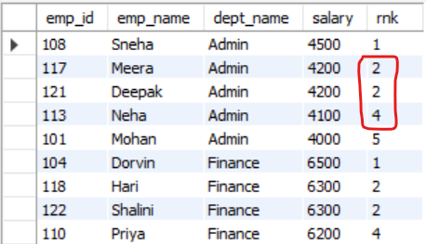

Short interview answer
RANK() is a window function that assigns ranks to rows based on a specified order. Rows with equal values receive the same rank, and the subsequent rank is skipped. With PARTITION BY, ranking restarts for each group.

- What is DENSE_RANK()?
DENSE_RANK() is a SQL window function that assigns ranks to rows based on the order specified inside the OVER() clause.
If two or more rows have the same value, they receive the same rank. Unlike RANK(), DENSE_RANK() does not skip the next rank after a tie.

For example,
SELECT *,DENSE_RANK() OVER(partition by dept_name order by salary desc) AS drnk
FROM employees

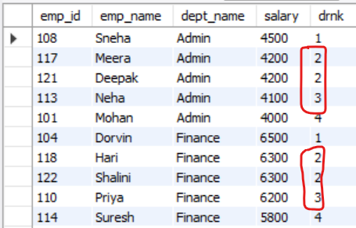

Short interview answer
DENSE_RANK() is a window function that assigns ranks to rows based on a specified order. Rows with equal values receive the same rank, and unlike RANK(), no rank numbers are skipped after ties.

- What is LAG()?
LAG() is a SQL window function that is used to access the value of a previous row from the current row, without using a self join.
It works based on the order defined inside the OVER() clause.
LAG() can also take an offset to look multiple rows back, and a default value can be provided if the previous row does not exist.
Example:
SELECT *,
LAG(salary) OVER(
PARTITION BY dept_name
ORDER BY emp_id
) AS prev_emp_salary
FROM employees;
Here, LAG(salary) returns the salary of the previous employee within the same department.

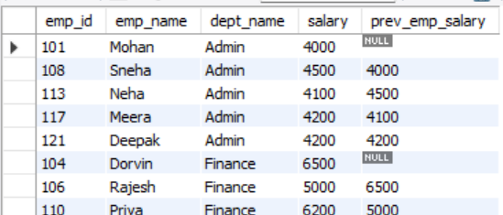
- fetch a query to display if the salary of an employee is higher,lower or equal to the pervious 2nd employee
Syntax
LAG(column_name, offset, default_value)
OVER(
PARTITION BY column_name
ORDER BY column_name
)
Example:
LAG(salary, 2, 0)
This means:
Return the salary from 2 rows before, and if that row does not exist, return 0.
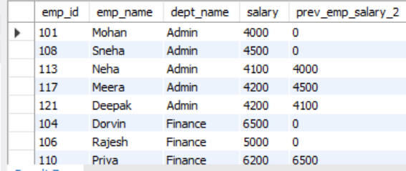
Short interview answer
LAG() is a window function used to access the value of a previous row without using a self join. It can retrieve one or more preceding rows based on the order specified in the OVER() clause.

- What is LEAD()?
LEAD() is a SQL window function used to access the value of a subsequent or next row from the current row, without using a self join.
It works according to the ordering specified inside the OVER() clause and can also use an offset to look multiple rows ahead.
Example:
SELECT *,
LEAD(salary) OVER(
PARTITION BY dept_name
ORDER BY emp_id
) AS next_emp_salary
FROM employees;
Here, LEAD(salary) returns the salary of the next employee within the same department based on salary order.
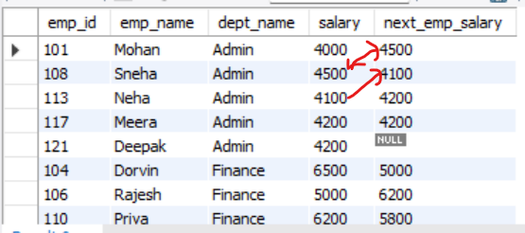
Syntax
LEAD(column_name, offset, default_value)
OVER(
PARTITION BY column_name
ORDER BY column_name
)
Example:
LEAD(salary, 2, 0)
means:
Return the salary from 2 rows ahead; if that row does not exist, return 0.
Short interview answer
LEAD() is a window function used to access the value of a following row without using a self join. It retrieves one or more subsequent rows based on the order defined in the OVER() clause.
And the easiest way to remember the pair is:
LAG() → looks backward
LEAD() → looks forward

